Miles Shinsato

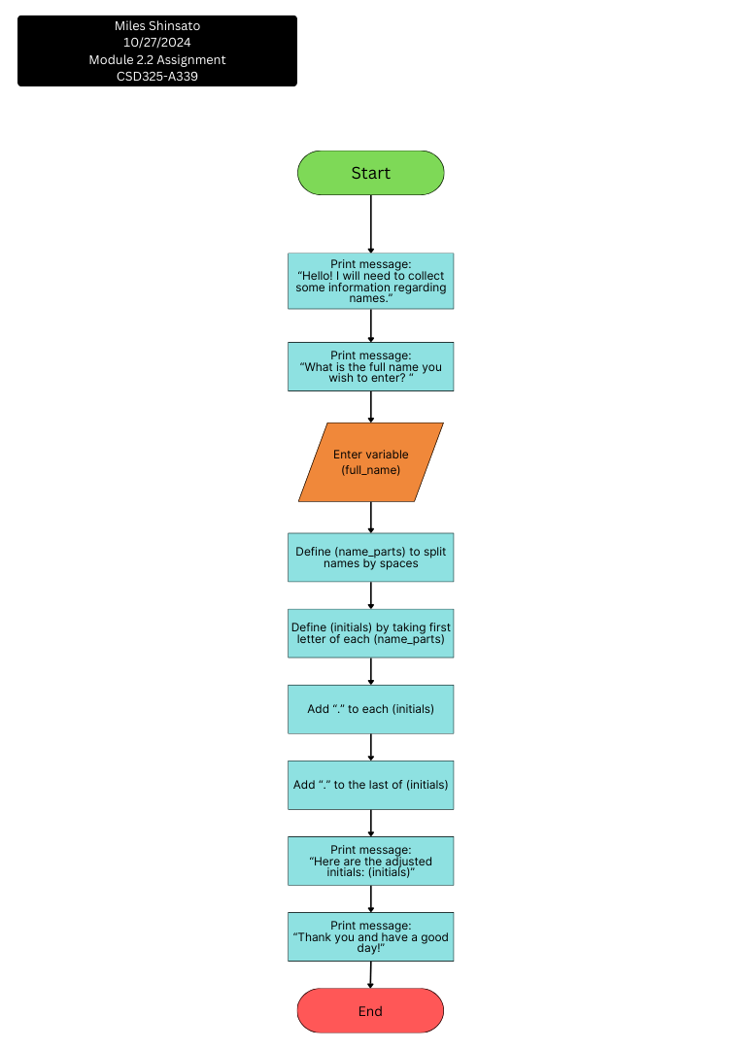10/27/2024

Module 2.2 Assignment Flowchart

CSD325-A339